**PetroChoice Face Recognition System:** Progress Report

**Date:** April 10, 2025  
**Prepared by:** Mostafa Magdy  
**Role:** AI Engineer

**1. Project Overview**

**1.1 Main Project: Safety System for Drilling Building**

PetroChoice is building a face recognition system to keep workers safe in a drilling building. The system uses four cameras to:

* Identify workers as they enter the building.
* Track where they go (like the second floor).
* Show a live report of everyone’s location.

This will help us know where workers are at all times, making the building safer and easier to manage.

**1.2 Demo Project: Testing the Idea**

Right now, we’re working on a smaller demo with three cameras in our office. The demo helps us:

* Collect face pictures from our team.
* Teach the system to recognize people.
* 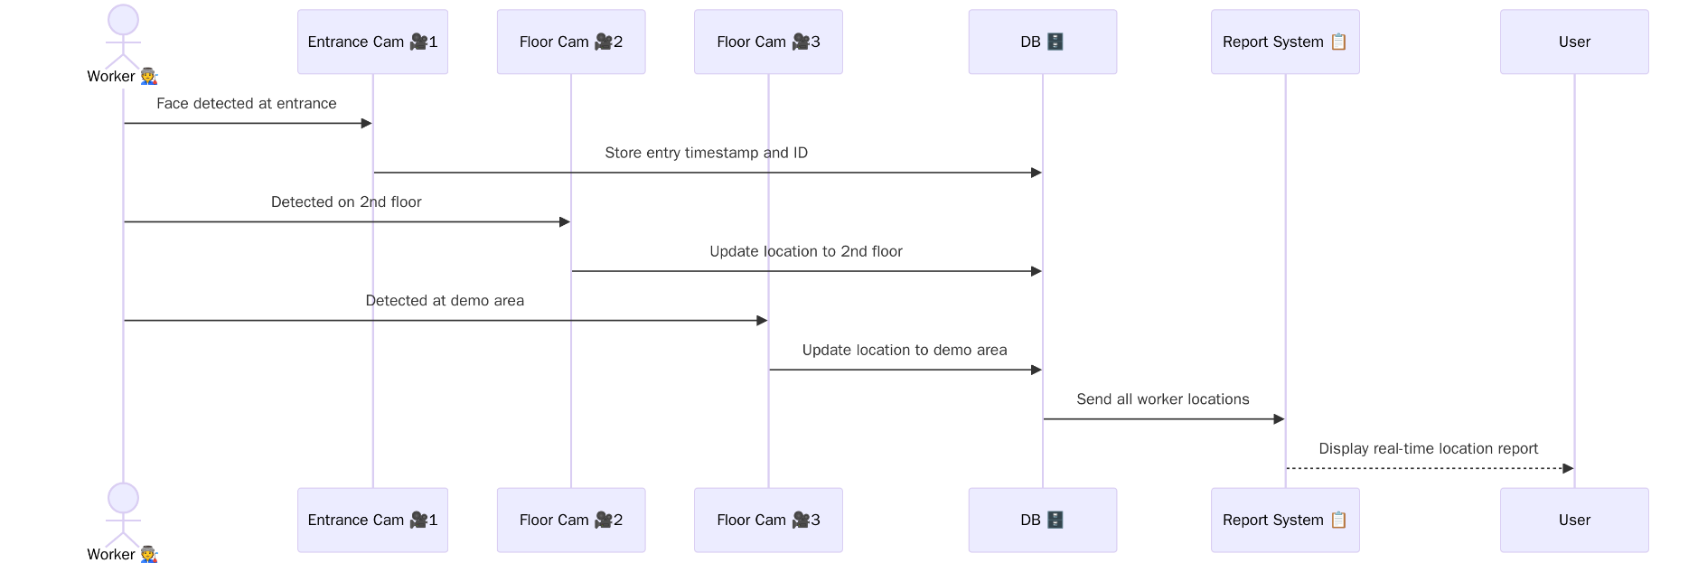Test if it works well before we use it in the drilling building.

**2. What We’ve Done So Far**

**2.1 Collecting Face Pictures**

We took pictures of nine people in our office to teach the system who’s who. The team members are:

* Eng. Mahmoud
* Eng. Mostafa
* Eng. Hagar
* Mrs. Dalia
* Mr. Yousef
* Gamila
* Mahmoud
* Ragab
* Abd Elrahman

We used one of the cameras in the office to snap these pictures and build our face collection.

**2.2 Small Steps Taken**

* **Set Up Three Cameras:** We placed three cameras—one at the entrance, one on “Floor 2,” and one in the office—to mimic the real setup.
* **Created a Scanning Program:** We made a simple program that scans faces from all three cameras every 5 seconds to collect data quickly.
* **Taught the System:** We used the face pictures to train the system to recognize our team.

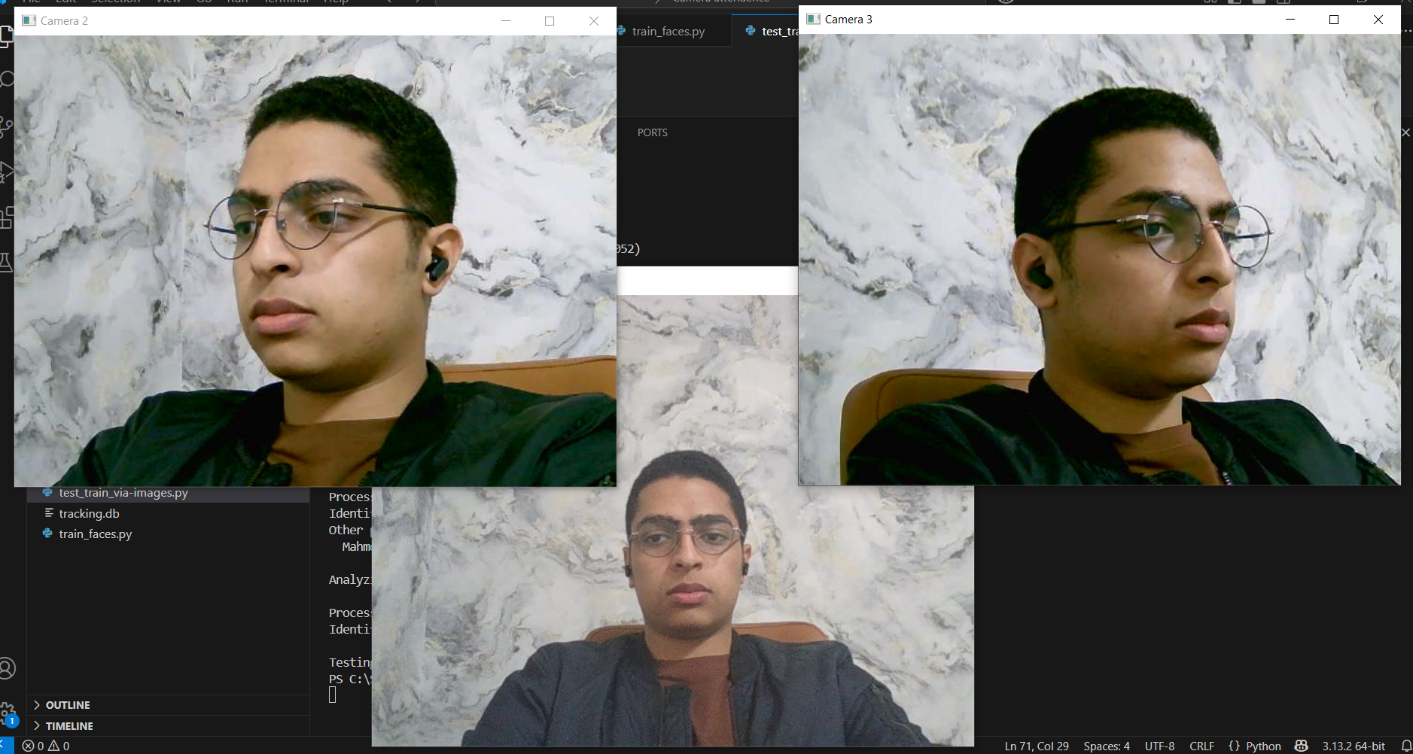

**2.3 Testing the System**

After training, we tested the system with new pictures of our team. Here’s how it did:

* **Dalia:** Recognized correctly (Accuracy: 95%)
* **Eng. Mahmoud:** Recognized correctly (Accuracy: 96%)
* **Gamila:** Recognized correctly (Accuracy: 97%)
* **Hagar:** Recognized correctly (Accuracy: 96%)
* **Mahmoud:** Recognized correctly (Accuracy: 92%)
* **Mostafa:** Recognized correctly (Accuracy: 94%)
* **Ragab:** Recognized correctly (Accuracy: 95%)
* **Yousef:** Recognized correctly (Accuracy: 98%)

The system worked well, recognizing everyone with high accuracy (92% or better). This shows it’s ready for the next steps.

**3. What’s Next**

* **Add More People:** Take pictures of more workers for the drilling building.
* **Use a Fourth Camera:** Add one more camera to complete the full setup.
* **Connect the program:** Connect the face recognition with report system via data base.
* **Improve the Report:** Make the location report easier to read and use.
* **Test in the Building:** Try the system in the real drilling building.
* **Make It Better:** Adjust the system so it works perfectly, even with tricky lighting.

**PetroChoice Face Recognition System:** Poster 1

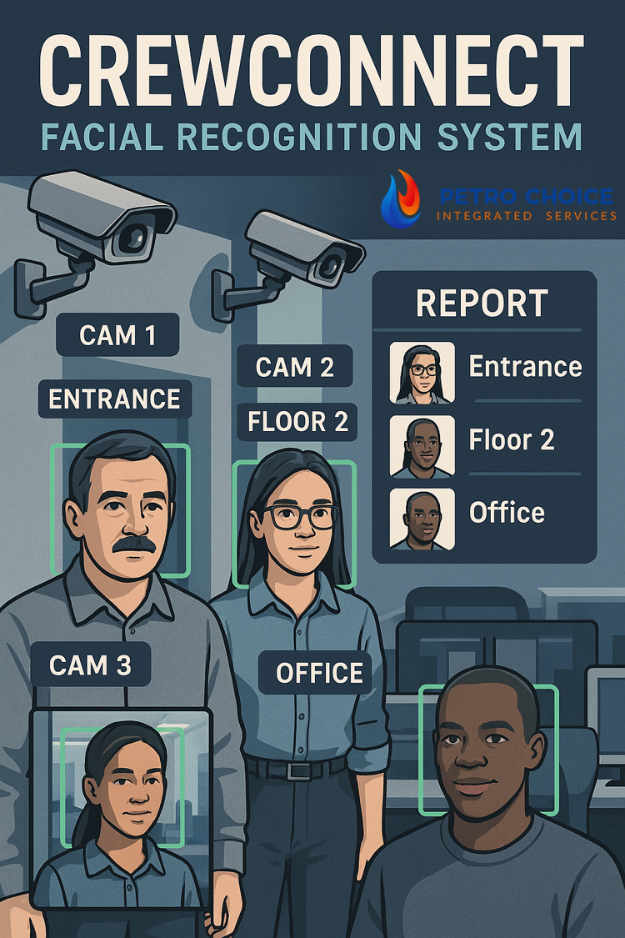

Poster 2

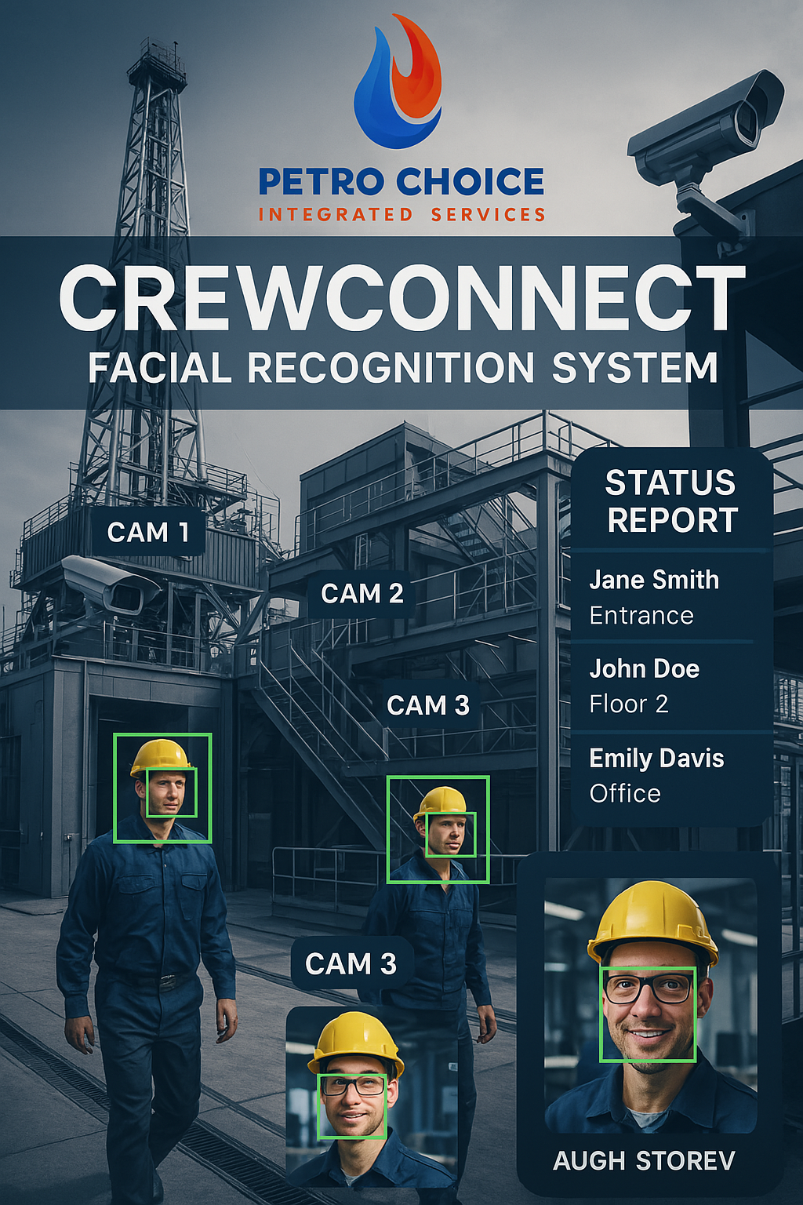

Mostafa